


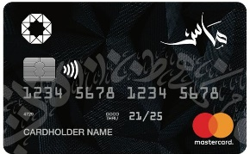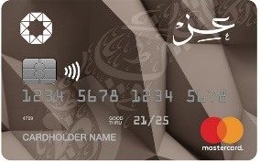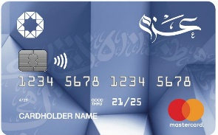
List Of Accredited Merchants For
The free installment via electronic Murabaha card



Merchant Name | Merchant Type | Min purchase/ Number of instalments (in accordance with transaction value) | Branches/ Contact No.
 | Car tires and rims | JOD (50-2000)  Up to 12 months | All Branches  0775551110  0775808000
 | Car tires and rims | JOD (100-3000)  Up to 12 months | Tabarbour  0778770000
 | Car tires and rims | JOD (100-5000)  Up to 12 months | Macca St.  065508080
 | Car tires and rims | JOD (100-5000)  Up to 12 months | Macca St.  065508080
 | Car tires and rims | JOD (100-5000)  Up to 12 months | Macca St.  065508080
 | Services and repair | JOD (20-200)  Up to 9 months  JOD (200.001- 1000)  Up to 12 months | Marka  0785968681  0797032839  0799144816
 | Services and repair | JOD (20-200)  Up to 6 months  JOD (200.001- Above)  Up to 12 months | Al Bayader  0777777805
 | Services and repair | JOD (20- Above)  Up to 12 months | All Branches

