


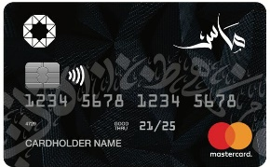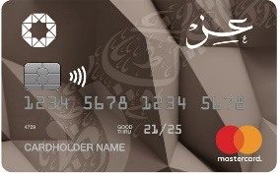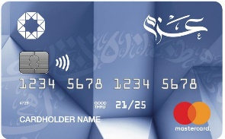
List Of Accredited Merchants For
The free installment via electronic Murabaha card



Merchant Name | Merchant Type | Min purchase/ Number of instalments (in accordance with transaction value) | Branches/ Contact No.
 | Carpets | JOD (20-150)  Up to 6 months  JOD (150.001-Above)  Up to 12 months | Swefieh  0791487372
 | Carpets | JOD (100-1500)  Up to 12 months | Mecca Street , Al-Jubaiha university street , Al-muqablain , Khalda , Dabouq  065533955  0777561111
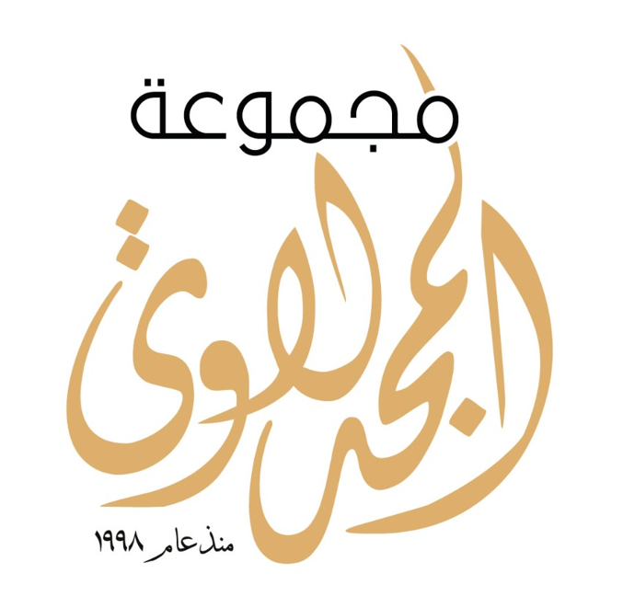 | Carpets | JOD (100-250)  Up to 6 months  JOD (250.001-Above)  Up to 12 months | All branches  0799296667  0777202121
 | Carpets | JOD (50-Above)  Up to 12 months | AL Mafraq  Al Jubaiha  Irbid  Medical City (Daboq)  Al Madinah Al Munawarah  Abdoun  East Madaba

