


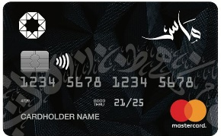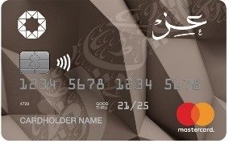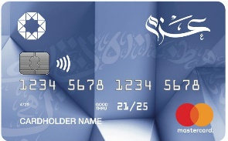
List Of Accredited Merchants For
The free installment via electronic Murabaha card



Merchant Name | Merchant Type | Min purchase/ Number of instalments (in accordance with transaction value) | Branches/ Contact No.
 | Electric Appliances  Electronics | JOD (200-Above)  Up to 12 months | All branches  065333332
 | Electric Appliances  Electronics | JOD (100-500)  Up to 6 months  JOD (500.001-1500)  Up to 9 months  JOD (1500.001-5000)  Up to 12 months | All branches  065809999
 | Electric Appliances  Electronics | JOD (100-200)  Up to 6 months  JOD (200.001-300)  Up to 12 months  JOD (300.001-500)  Up to 24 months  JOD (500.001-Above)  Up to 36 months | All branches  064777777
 | Electric Appliances  Electronics | JOD (100-300)  Up to 6 months  JOD (300.001-1000)  Up to 9 months  JOD (1000.001-Above)  Up to 12 months | All branches  064201050
 | Electric Appliances  Electronics | JOD (100-249)  Up to 12 months  JOD (249.001-499)  Up to 24 months  JOD (499.001- Above)  Up to 36 months | All branches  0798516775
 | Electric Appliances  For Agencies and Corporates  ( Hitachi , Benkon , Glem Gas ) | JOD (50-250)  Up to 6 months  JOD (250.001- Above)  Up to 12 months | All branches  065885882
 | Electric Appliances  Electronics | JOD (200-300)  Up to 6 months  JOD (300.001-Above)  Up to 12 months | All branches  0799093917  0799093914
 | Electric Appliances  Electronics | JOD (100-500)  Up to 12 months  JOD (500.001- 1000)  Up to 24 months  JOD (1000.001-10000)  Up to 36 months | All branches  064009999
 | Electric Appliances  Electronics | JOD (50-1000)  Up to 9 months  JOD (1000.001-5000)  Up to 12 months  JOD (5000.001-Above)  Up to 24 months | All branches  0793555553
 | Electric Appliances  Electronics | JOD (100-500)  Up to 12 months  JOD (500.001-3000)  Up to 24 months  JOD (3000.001- Above)  Up to 36 months | All branches  065806262
 | Electric Appliances  Electronics | JOD (100-Above)  Up to 12 months | AL-Sweifieh  0790791144
 | Electric Appliances  Electronics | JOD (50-100)  Up to 9 months  JOD (100.001-500)  Up to 12 months  JOD (500.001- Above)  Up to 24 months | All branches  0791300220  065527630
 | Electric Appliances  Electronics | JOD (20-500)  Up to 12 months  JOD (500.001 – Above)  Up to 24 months | All branches  065541220
 | Electric Appliances  Electronics | JOD (150-300)  Up to 12 months  JOD (300.001 – 500)  Up to 24 months  JOD (500.001 – Above)  Up to 36 months | All branches  065777155
 | Electric Appliances  Electronics | JOD (50-250)  Up to 6 months  JOD (250.001- Above)  Up to 12 months | All branches  065885882
 | Electric Appliances  Electronics | JOD (100-250)  Up to 6 months  JOD (250.001- 2000)  Up to 12 months | Al Muqabalayn  0795356595
 | Electric Appliances  Electronics  (Except Mobile) | JOD (20-250)  Up to 6 months  JOD (250.001-500)  Up to 9 months  JOD (500.001-2000)  Up to 12 months  JOD (2000-5000)  Up to 24 months | Swieleh  0790859090
 | Electric Appliances  Electronics | JOD (100-400)  Up to 12 months  JOD (400.001-750)  Up to 24 months  JOD (750.001- Above)  Up to 36 months | All branches  0796000777
 | Electric Appliances  Electronics | JOD (50-249)  Up to 6 months  JOD (249.001-699)  Up to 9 months  JOD (699.001-2000)  Up to 12 months | AL Musdar  0788373707
 | Electric Appliances  Electronics | JOD (100-150)  Up to 12 months  JOD (151 -5000)  Up to 24 months | All branches  0780785050
 | Electric  Appliances  Electronics | JOD (100-2000)  Up to 12 months  JOD (2001 –above )  Up to 24 months | All branches  065000015
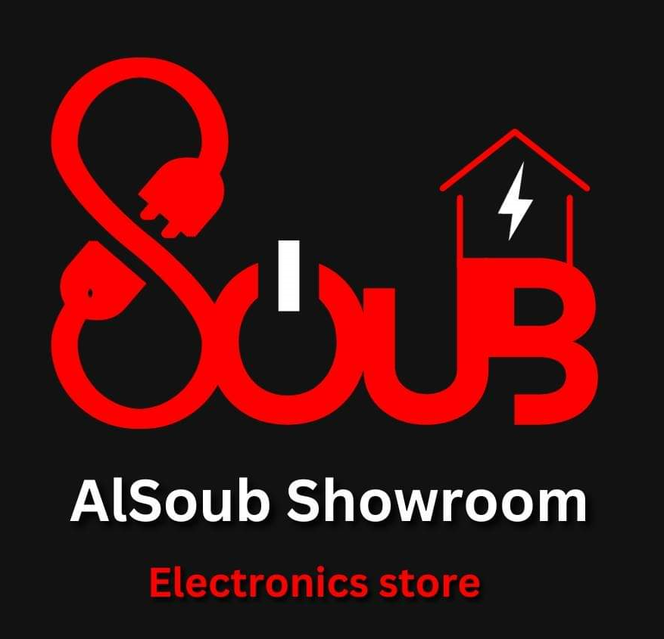 | Electric Appliances  Electronics | JOD (20-200)  Up to 6 months  JOD (200.001-5000)  Up to 12 months | AL Karak  0795137877
 | Electric Appliances  Electronics | JOD (200-Above)  Up to 12 months | AL-Hurriyah  0791200121
 | Electric Appliances  Electronics | JOD (200-Above)  Up to 12 months | Swefieh  0775444436
 | Electric Appliances  Electronics  (Website) | JOD (50-200)  Up to 6 months  JOD (200.001-10000)  Up to 12 months | Swefieh  0775444436
 | Electric Appliances  Electronics  (Website) | JOD (100-200)  Up to 6 months  JOD (200.001-3000)  Up to 12 months  JOD (3000.001 -5000)  Up to 24 months  JOD (5000.001 -Above)  Up to 36 months | Madina Munawara St.  0796872724
 | Electric Appliances  Electronics  Furniture | JOD (100-500)  Up to 6 months  JOD (500.001 -1000)  Up to 12 months  JOD (1000.001 -2000)  Up to 24 months  JOD (2000.001 -Above)  Up to 36 months | AlQuwismeh  0791802370
 | Electrical Supplies | JOD (50-249)  Up to 6 months  JOD (249.001-699)  Up to 9 months  JOD (699.001-2000)  Up to 12 months | Dabouq  0778800534
 | Electric Appliances  Electronics | JOD (100-Above)  Up to 12 months | Al Karak  0796164449  0792380187
 | Electric Appliances  Electronics | JOD (100-Above)  Up to 12 months | Al Karak  0792583332

