


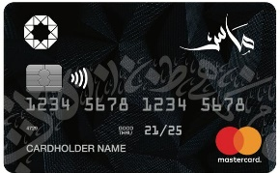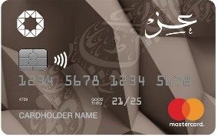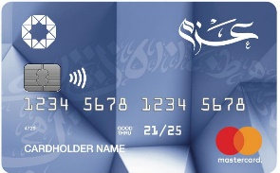
List Of Accredited Merchants For
The free installment via electronic Murabaha card



Merchant Name | Merchant Type | Min purchase/ Number of instalments (in accordance with transaction value) | Branches/ Contact No.
 | Heating & Air Conditioning | JOD (200-350)  Up to 12 months  JOD (350.001-Above)  Up to 24 months | Al Waha Circle.  Mecca Street.  0790322222
 | Heating & Air Conditioning | JOD (200-300)  Up to 6 months  JOD (300.001-Above)  Up to 12 months | Irbid – Dwar Aleyadat  0772844423
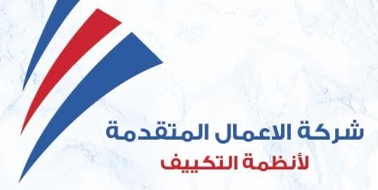 | Heating & Air Conditioning | JOD (250-500)  Up to 9 months  JOD (500.001-Above)  Up to 12 months | Khalda  0791010207  0791010208
 | Heating & Air Conditioning | JOD (100 -3000)  Up to 12 months  JOD (3000.001 -5000)  Up to 24 months  JOD (5000.001 -6500)  Up to 36 months | Aqaba  0797329742
 | Electric Appliances  Heating & Air Conditioning | JOD (100-500)  Up to 6 months  JOD (500.001-2000)  Up to 12 months | As Salt  0779999595  0779999393
 | Heating & Air Conditioning | JOD (250-350)  Up to 9 months  JOD (350.001-5000)  Up to 12 months | Khalda  065373711
 | Heating & Air Conditioning | JOD (100-300)  Up to 6 months  JOD (300.001-500)  Up to 9 months  JOD (500.001-1000)  Up to 12 months  JOD (1000.001 - 3000)  Up to 24 months  JOD (3000.001 - Above)  Up to 36 months | Khalda  0798885066
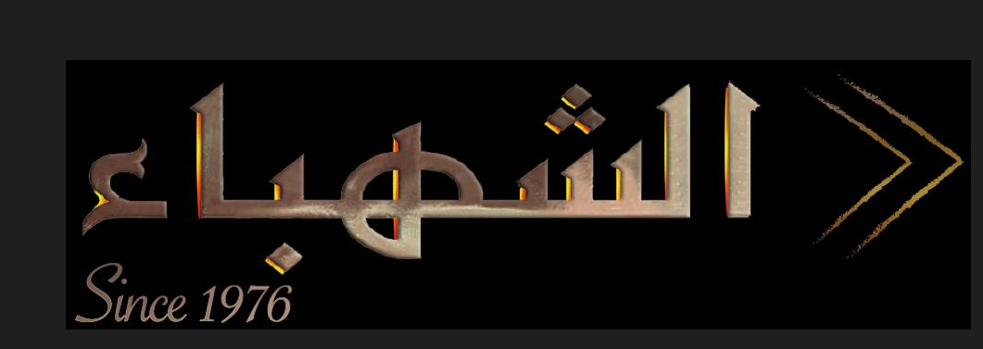 | Central heating | JOD (100-500)  Up to 6 months  JOD (500.001-10000)  Up to 12 months | Khalda  065532783
 | Healthy tools &  Air Conditioning | JOD (100-499.99)  Up to 6 months  JOD (500-10000)  Up to 12 months | All branches  065500022  0771035900
 | Electric Appliances  Heating & Air Conditioning | JOD (150-300)  Up to 6 months  JOD (300.001-1000)  Up to 9 months  JOD (1000.001-5000)  Up to 12 months | Khalda  0777055590  065523410
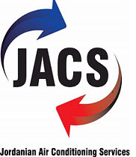 | Electric Appliances  Heating & Air Conditioning | JOD (50-500)  Up to 6 months  JOD (500.001-5000)  Up to 12 months  JOD (5000.001-10000)  Up to 24 months | Al Madina alMunawara St.  0777715815
 | Electric Appliances  Heating & Air Conditioning | JOD (300-1000)  Up to 9 months  JOD (1000.001-2400)  Up to 12 months  JOD (2400.001-4000)  Up to 24 months | Khalda  065562990
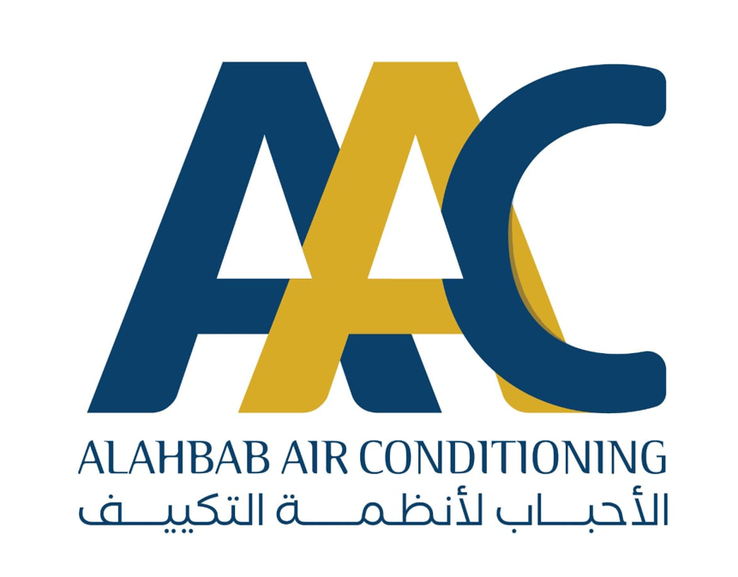 | Air Conditioning | JOD (200 -800)  Up to 12 months  JOD (800.001-Above)  Up to 24 months | Abdali  0785467555  0799750503

