


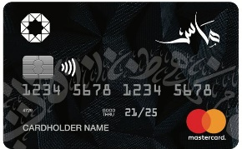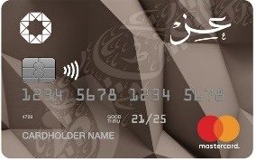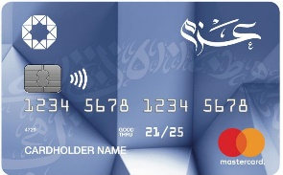
List Of Accredited Merchants For
The free installment via electronic Murabaha card



Merchant Name | Merchant Type | Min purchase/ Number of instalments (in accordance with transaction value) | Branches/ Contact No.
 | Mobile phones  Electronics | JOD (300-499.999)  Up to 6 months  JOD (500-10000)  Up to 12 months | All branches  0799595662
 | Mobile phones  Electronics  Accessories | JOD (100-1000)  Up to 9 months  JOD (1000-5000)  Up to 12 months | All branches  065903555
 | Mobile phones  Electronics  Accessories | JOD (100-4000)  Up to 12 months | All branches  0770606010
 | Mobile phones | JOD (300-1250)  Up to 12 months  JOD (1251 -Above)  Up to 24 months | All branches  0790777900
 | Mobile phones | JOD (20-100)  Up to 12 months  JOD (101-300 )  Up to 24 months  JOD (301-above )  Up to 36 months | All branches  0775448898
 | Mobile phones | JOD (100-400 )  Up to 12 months  JOD (401-600)  Up to 24 months  JOD (601- 1000)  Up to 36 months | All branches  065509040
 | Mobile phones | JOD (100-200)  Up to 12 months  JOD (201-10000)  Up to 24 months | All branches  0797848487
 | Mobile phones | JOD (100-10000)  Up to 12 months | Al Raya Mall  0796669532
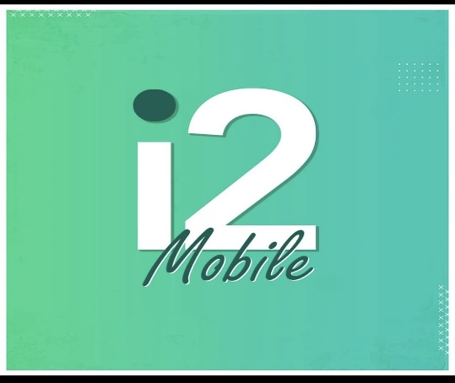 | Mobile phones | (250-1000) JOD  Up to 12 Months  (1000.01 -3000) JOD  Up to 24 Months | Jarash  0778100200
 | Mobile phones | (50-400) JOD  Up to 12 Months  (401-2000)  Up to 24 Months  (2001- 3000)  Up to 36 Months | Aljabal alshamali  Yajouz  062223700
 | Electric Appliances  & Mobile phones | JOD (20-500)  Up to 9 months  JOD (500.001 -1100)  Up to 12 months  JOD (1100.001 -2000)  Up to 24 months  JOD (2000.001 -Above)  Up to 36 months | Madaba  0796667071
 | Mobile phones  Electronics  Accessories | JOD (100-500)  Up to 6 months  JOD (500.001-2000)  Up to 12 months | Mecca St.  065100250
 | Mobile phones  Electronics  Accessories | JOD (400-Above)  Up to 12 months | Irbid  0797979787
 | Mobile phones  Electronics  Accessories | JOD (100-500)  Up to 6 months  JOD (500.001-2000)  Up to 12 months | All branches  065858500

